**Ethics** in **IT**

**Class 8**

**Lab 2**

|  |
| --- |
| Lab Objectives:Ethics in School |

# Ethics and Morality

## Ethics and morals are often associated with religion, but schools can also provide important lessons in ethical thinking and action.

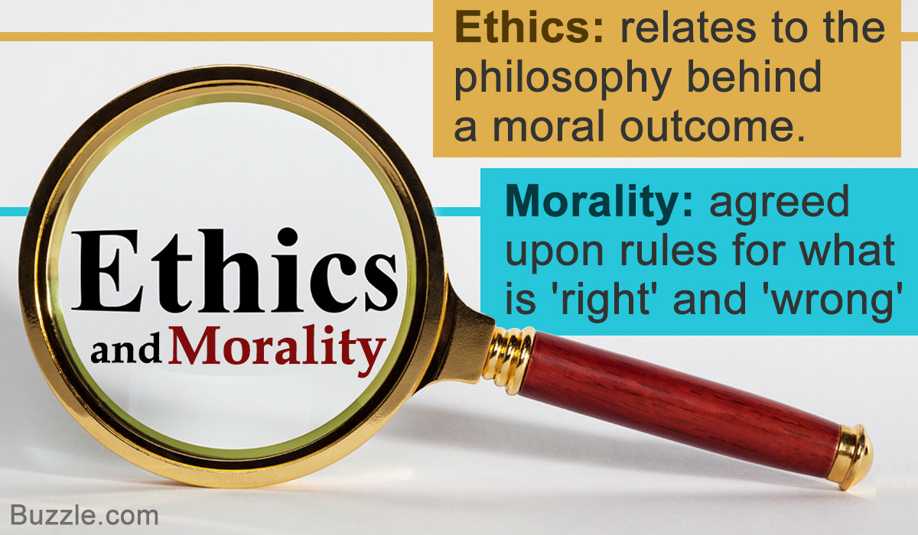

# Basic Principle

## there are five basic principles of ethics that are common to all faiths:

## Do no harm

## Make things better

## Respect others

## Be fair

## Be loving

# Do No Harm

## Try not to hurt people. If hurting others is unavoidable, for example, in breaking up with someone or firing someone, it’s important to minimize the hurt. Say just enough to make the point clear; don’t say anything that will hurt the person unnecessarily. It’s important to not be hurtful to people who don’t fit the mainstream, whether it’s a student who is physically disable.



# Make Things Better

## It’s important to help people—and to know the difference between helping and hurting. If you’re a teacher, assign only the amount of homework that is helpful. If there’s a new kid in school, make him feel welcome. If you see someone in need, lend a helping hand. Say something kind. Make people feel good about themselves. Be a part of creating a community where people trust one another. If you don’t have trust in a community, people won’t take risks and won’t share who they really are.



# Respect Others

## We show respect by telling the truth, keeping our promises, and not listening to or spreading rumors. If someone tells you a secret, don’t tell anyone else. Don’t treat a child with disrespect or neglect. Don’t crush a child’s spirit. One of the primary goals in a school is to create a community with varying talents that flourish. One of the foundation values for that, is respect—respecting one another and our differences.

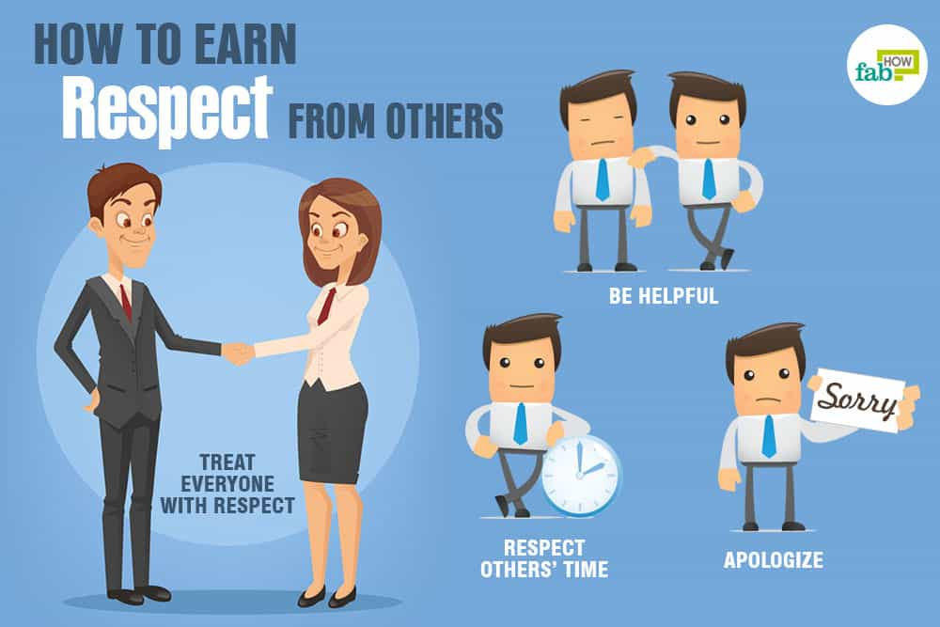

# Be Fair

Fairness has to do with how we punish people,Don’t punish too harshly because you are emotional. Make sure your punishment fits the crime. Fairness also has to do with how we distribute scarce resources. Don’t favor some students. Don’t give more to some and less to others. Finally, fairness has to do with a willingness to turn an unjust situation into a just one. If a teacher is verbally abusive, the ethical teacher will stick his neck out and get involved. If a student is being bullied, the ethical student will step in.

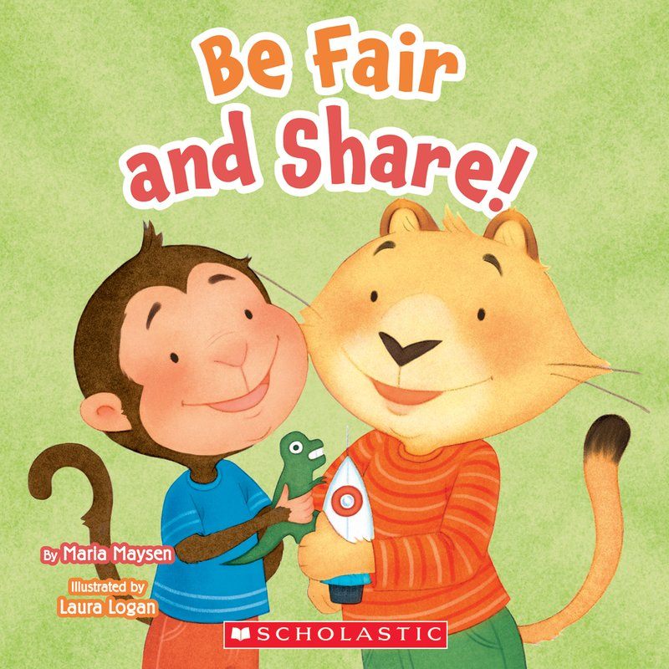

# Be Loving

## Part of being loving, Show people you care about them. Learning to give your time and energy in service to a just cause does not only create a better world, it also provides great personal satisfaction and helps you be more loving. Identify a cause you believe in and locate a related volunteer organization in your area.

## For instance, if you’re passionate about animal rights and environmentalism, you could volunteer with your local animal shelter or conservation group.

